**Eliminate Duplication By Inheritance**

*classes with similar responsibilities duplicate code to implement similar features*

*factor out the commonalities and host them in a joint parent class*

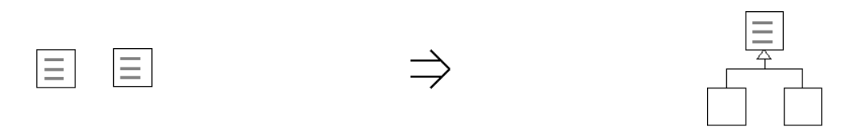

**Context:**

[Eliminate Duplication By Inheritance](https://web.archive.org/web/20090914100939/http:/www.refactoring.be/thumbnails/rtn-edbi.html) is a natural route towards abstraction after some required functionality has been brought in place quickly by [Introduce Duplication](https://web.archive.org/web/20090914100939/http:/www.refactoring.be/thumbnails/rtn-id.html).

[Eliminate Duplication By Inheritance](https://web.archive.org/web/20090914100939/http:/www.refactoring.be/thumbnails/rtn-edbi.html) is a key refactoring in [Evolving to the Strategy Pattern](https://web.archive.org/web/20090914100939/http:/www.refactoring.be/thumbnails/ec-strategy.html)

See also :[Eliminate Duplication By Composition](https://web.archive.org/web/20090914100939/http:/www.refactoring.be/thumbnails/rtn-edbc.html),[Replace Template With Strategy](https://web.archive.org/web/20090914100939/http:/www.refactoring.be/thumbnails/rtn-rtswss.html),*Extract Superclass[Fowler]*